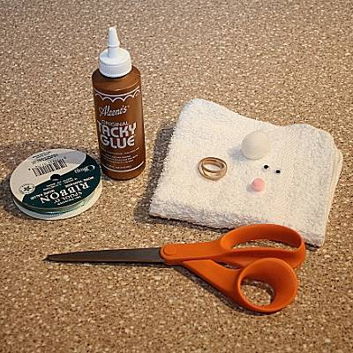
Your Materials:
Washcloth
Rubber band
Ribbon
Googly eyes, 2 pom poms

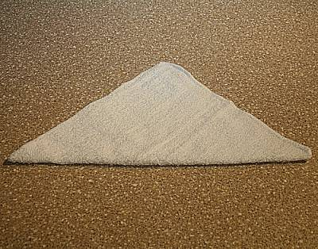
Step 1:
Start out by laying the wash rag flat on your work
surface. Fold up one of the corners so it looks like a triangle.

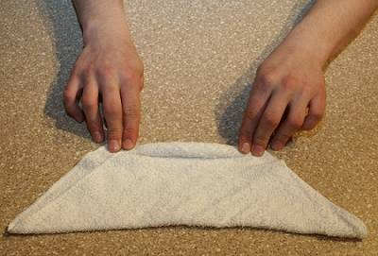
Step 2:
Start at the side of the wash rag that has two pointed edges together and tightly roll up the wash rag.

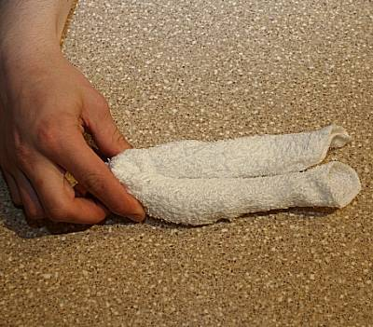
Step 3:
Now, fold the rolled wash rag in half as in the photo.

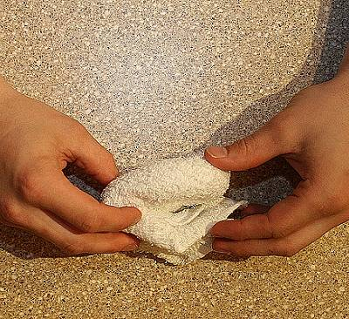
Step 4:
Fold the wash rag in half again as shown above.

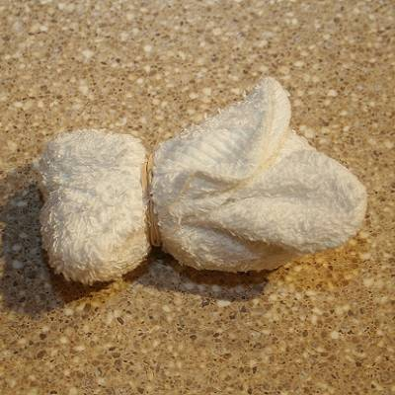
Step 5:
Hold the folded wash rag tightly and carefully wrap the rubber band around the end with the second fold. The rubber band should be a little closer to the folded edge, which will be the bunny's head.

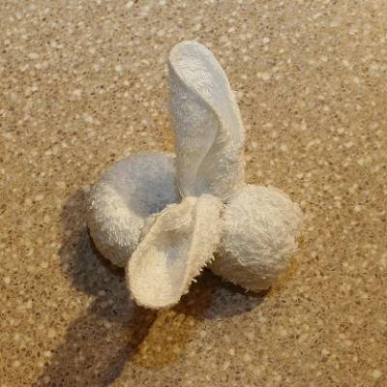
Step 6:
Set your wash rag down on your work surface and 'fluff' out the ears, which are on the opposite side of the rubber band as the bunny's head.

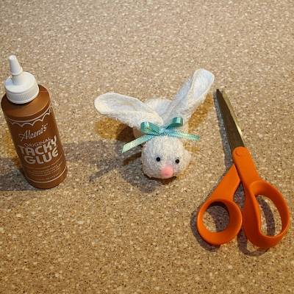
Step 7:
Now glue the eyes in place along with a small pom-pom to be the bunny's nose. Tie the ribbon around the rubber band. Finally, glue a 1-inch pom-pom onto the back of the bunny's body to be its tail.

*You may want to add this poem for fun!

If a boo boo has you feeling crummy,
Stick an ice cube in my tummy.
Hold it to your boo boo tight,
Soon everything will be all right!

